ASSIGNMENT 4

Que 1. write a select command that produce the order number, amount , and date for all rows in the orders table .
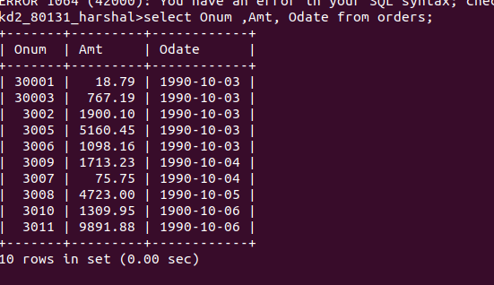
Que 2. write a query that produces all rows from the customers table for which the salespeoples number is 1001.
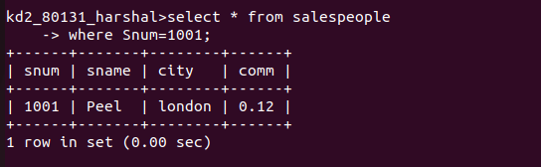

Que 3. write a query that displays the salespeople table with the columns in the following order : city , sname , snum, comm.
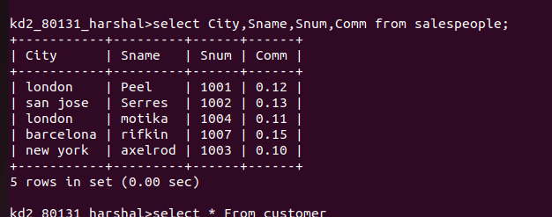

Que 4. write a select command that produces the rating followed by the name of each customer in san jose.

